The 2014 High Performance Computing & Simulation International Conference
(HPCS 2014)
July 21 - 25, 2014
Bologna, Italy

WEDNESDAY KEYNOTE

Big Data at the Intersection of Clouds and HPC

Geoffrey C. Fox
School of Informatics and Computing
Indiana University - Bloomington
Indiana, USA
gcf@indiana.edu

ABSTRACT
There is perhaps a broad consensus as to important issues in practical parallel computing as applied to large scale simulations; this is reflected in supercomputer architectures, algorithms, libraries, languages, compilers and best practice for application development. However, the same is not so true for data intensive computing, even though commercially clouds devote much more resources to data analytics than supercomputers devote to simulations.

We look at a sample of over 50 big data applications to identify characteristics of data intensive applications and to deduce needed runtime and architectures. We suggest a big data version of the famous Berkeley dwarfs and NAS parallel benchmarks and use these to identify a few key classes of hardware/software architectures. Our analysis builds on combining HPC and the Apache software stack that is well used in modern cloud computing. Initial results on academic and commercial clouds and HPC Clusters will be presented. One suggestion from this work is value of a high performance Java (Grande) runtime that supports simulations and big data.

SPEAKER BIOGRAPHY AND PHOTO
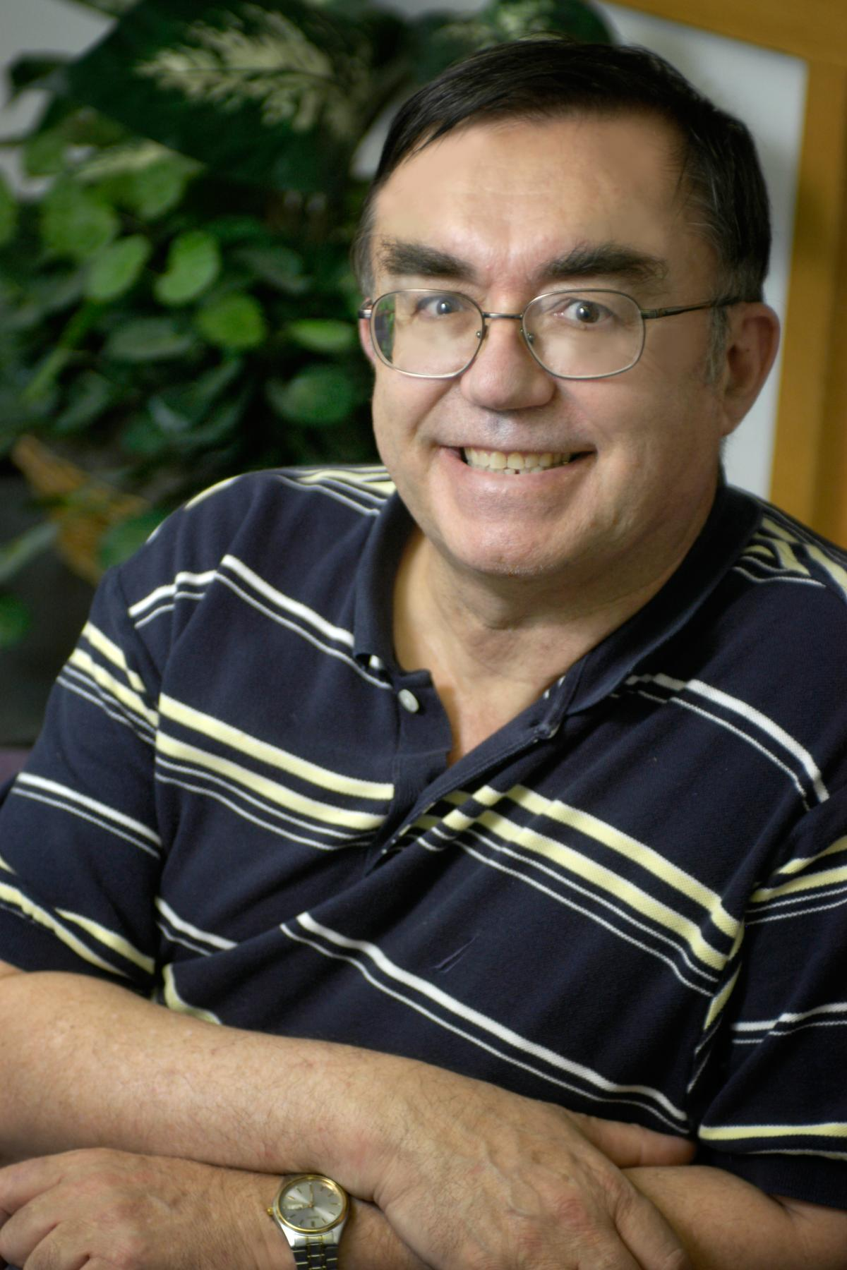
Geoffrey Charles Fox (gcf@indiana.edu, http://www.infomall.org).
Fox received a Ph.D. in Theoretical Physics from Cambridge University and is now distinguished professor of Informatics and Computing, and Physics at Indiana University where he is director of the Community Grids Laboratory and Associate Dean for Research and Director of the Data Science program at the School of Informatics and Computing. He previously held positions at Caltech, Syracuse University and Florida State University. He has supervised the PhD of 66 students and published around 1000 papers in physics and computer science with an hindex of 69 and over 25000 citations.
He currently works in applying computer science to Bioinformatics, Sensor Clouds, Earthquake and Ice-sheet Science, and Particle Physics. He is principal investigator of FutureGrid – a facility to enable development of new approaches to computing including clouds, grids and distributed systems. He is involved in several projects to enhance the capabilities of Minority Serving Institutions including the eHumanity portal. He has experience in online education and its use in MOOC’s for areas like Data and Computational Science. He is a Fellow of APS and ACM.

